**VNM FORCE FEEDBACK CONTROLER USER MANUAL**

# **1. Function Overview**

VNM FFB Controller Analog V1 and VNM FFB Controller CAN V1 have same PCB just has different control module. VNM FFB Controller Analog V1 has an external DAC while VNM FFB Controller CAN V1 has isolated CAN transceiver. It uses VNM WHEELBASE FIRMWARE V2. It need an adapter 24V >= 1A to isolate signal from servo and controller.

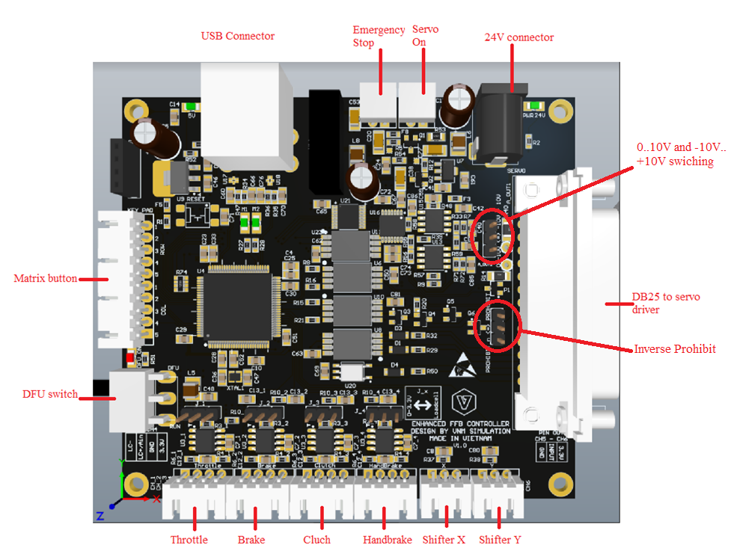

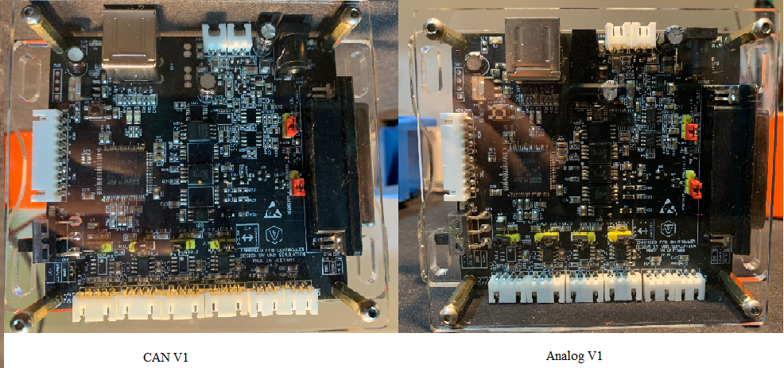

|  |  |  |  |
| --- | --- | --- | --- |
| **No** | **Feature** | **VNM FFB Controller Analog V1** | **VNM FFB Controller CAN V1** |
| 1 | Read incremental encoder | yes | No |
| 2 | Analog control | yes | No |
| 3 | CAN control | no | yes |
| 4 | prohibit | yes | yes (some servo doesn’t accept input from DI after enabling CAN) |
| 5 | Emergency stop | yes | yes (some servo doesn’t accept input from DI after enabling CAN) |
| 6 | Servo on | yes | yes (some servo doesn’t accept input from DI after enabling CAN) |
| 7 | Analog throttle | yes | yes |
| 8 | Analog clutch | yes | yes |
| 9 | analog brake | yes | yes |
| 10 | loadcel brake | yes | yes |
| 11 | analog handbrake | yes | yes |
| 12 | loadcel brake | yes | yes |
| 13 | XY shifter | yes | yes |
| 14 | matrix button | yes | yes |

# **2. Connection**

## **2.1. Connect Power supply for servo driver**

There are 2 ways can cause noise (EMI) to PC. The 1st one is from power supply and the second one is from Servo Signal Connection. With Servo signal connection, VNM FFB controller isolates servo driver and PC. To reduce the noise, you need a Noise Filter on the power supply cable for servo driver too. Connection as the following image. This is importance to reduce all noise.

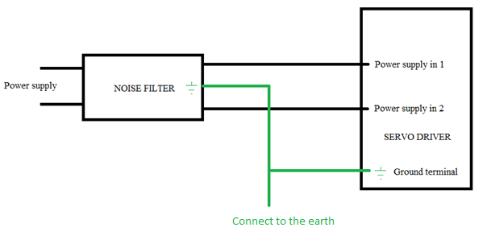

## **2.2. DB25**

This connector is used to connect to servo driver only

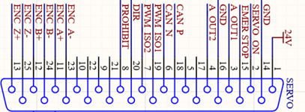

**Here is example for Mige and AASD driver. An example for HNC is in “HNC Configuration CANOPEN”.**

|  |  |  |  |
| --- | --- | --- | --- |
| **VNM FFB Controller DB25 pin number** | **description** | **Mige servo driver DB36 pin number** | **AASD servo driver DB25 pin number** |
| 1 | 24V | 18 | 9 |
| 2 | Servo On | 10 | 6 |
| 3 | Analog Out 1 | 19 | 25 |
| 4 | Analog Out 2 | 20 |  |
| 5 |  |  |  |
| 6 | CAN LOW |  |  |
| 7 | PWM2 |  |  |
| 8 | Prohibit | 13,14 | 8,24 |
| 9 |  |  |  |
| 10 |  |  |  |
| 11 | Encoder A+ | 1 | 20 |
| 12 | Encoder B+ | 3 | 18 |
| 13 | Encoder Z+ | 5 | 15 |
| 14 | GND | 23 | 13 |
| 15 | Emergency Stop |  |  |
| 16 | GND |  | 10 |
| 17 |  |  |  |
| 18 | CAN HIGH |  |  |
| 19 | PWM1 |  |  |
| 20 | DIR |  | 7 |
| 21 |  |  |  |
| 22 |  |  |  |
| 23 | Encoder A- | 2 | 19 |
| 24 | Encoder B- | 4 | 17 |
| 25 | Encoder Z- | 6 | 16 |

## **2.3. USB Connector**

The upper USB connection is used for debug.

The lower USB connection is used for FFB controller.

## **2.4. Pedal/handbrake connector**

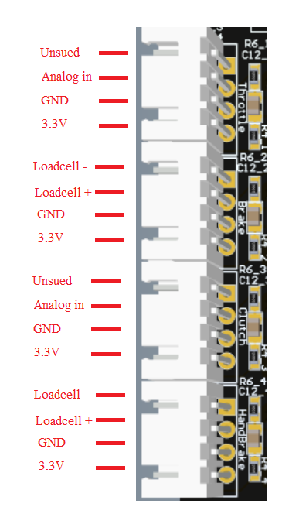

VNM FFB controller uses potentiometers for throttle and clutch only. Brake and handbrake can be loadcells or potentiometers by changing jumps (loadcell as default)

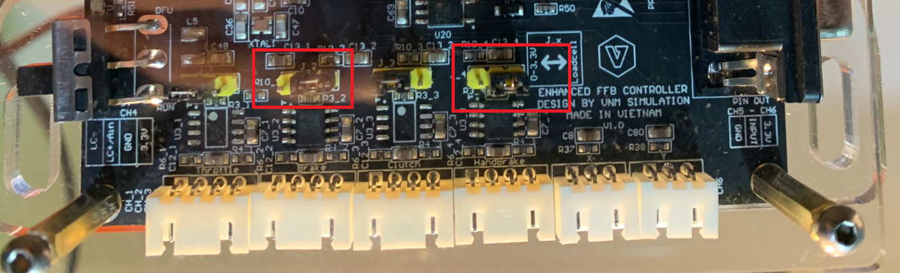

## **2.5. XY Shifter**

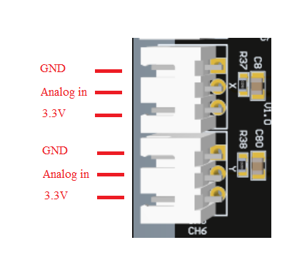

## **2.6. Matrix button**

Matrix button can use for button box, steering wheel or event shifter.

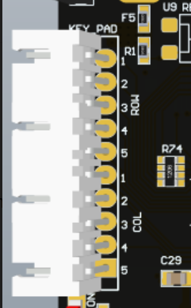

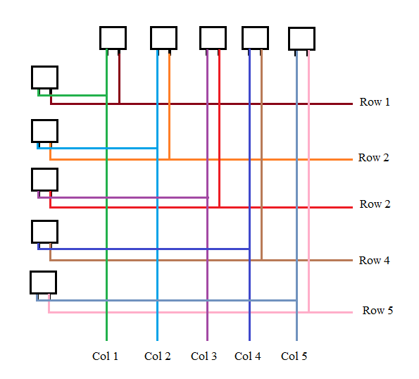

## **2.7. Servo on-Emergency**

Base on each type of servo driver, you can choose the button is Normal Open (NO) or Normal Close (NC) button.

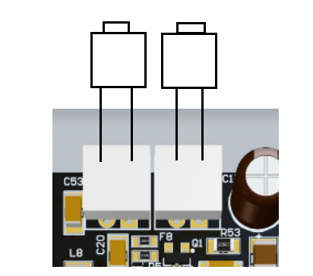

## **2.7. Switch 0..10V and -10V..10V**

Default it is 0..10V mode, if your server use +- 10v to control, change jump to -+10V.

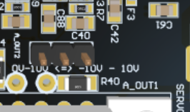

## **2.8. Inverse prohibit**

This is used to inverse signal from high to low and vise versa. Some servo use high to prohibit servo turn, some use low to prohibit.

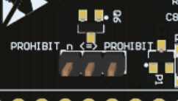

## **2.9. DFU switch**

This switch to you enable DFU mode to upgrade firmware. If the light near switch turn on that show it is in DFU mode.

